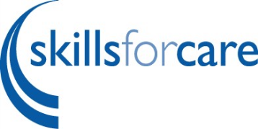

Safer employment

00:02
Safer employment is about embedding a safeguarding mindset at every stage of the employment journey. It's a key way to create a safeguarding culture by focusing on who and how you recruit, and how you manage staff. The PRISIM model of safer employment supports employers to understand how to apply a safeguarding mindset from planning recruitment to managing leavers.

00:39
A safeguarding mindset is the difference between compliance and curiosity. We know that a culture of compliance alone does not keep people safe. As an employer, you need to be curious and if something doesn't seem right, seek additional information so you have the evidence to make the right decisions. PRISM supports employers to move beyond compliance, to fulfil your responsibilities and keep everyone safe. The model highlights the six stages of the safer employment journey.

P - planning to recruit, building a safeguarding mindset into every stage of your recruitment and vetting process.
R - recruitment and vetting, identifying safeguarding and conduct concerns to prevent unsuitable people from coming to work with you.
I - induction and probation, setting clear expectations of conduct and behaviour and identifying and managing concerns from the beginning.
S - supervising and managing using a safeguarding mindset when regularly supervising staff, identifying and managing concerns before they escalate.
I - identifying and managing concerns encouraging an open culture where concerns are shared and effectively responded to keeping everyone safe.
M - managing levers and referring information, gathering conduct and safeguarding information when people leave and using a safeguarding mindset to share and refer relevant information.

At every stage, employers are encouraged to gather all relevant information about concerns and record the information in a format where it can be shared with others where relevant so that you can fulfil your safeguarding responsibilities are safer employment guide provides you with resources, including templates and checklists to help you follow effective safer employment processes and evidence it safeguarding is everyone's responsibility. So get started on your safer employment journey.

Visit www.SkillsForCare.org.uk/SaferEmployment

